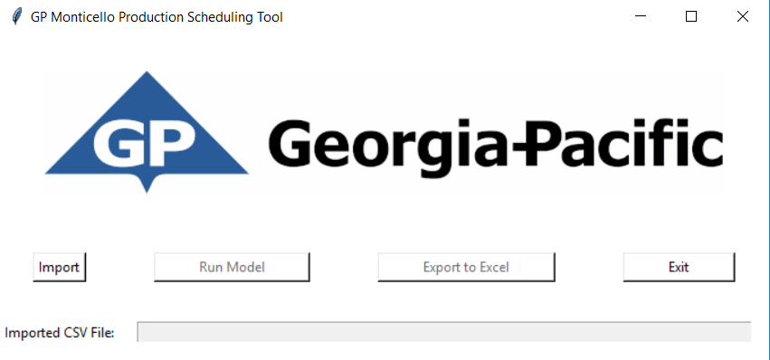

Welcome to the Georgia-Pacific Monticello Optimal SKU Sequencing Tool! This read-me will walk you through the process of uploading the orders for the upcoming week and producing an optimal run sequence.

# Step 1: Importing Your Orders

First you will want to create a .csv file in the correct format. A template file has been included for your use as well (TemplateforProductionSchedulingCSV.csv). The file must be in the format (Product ID, SKU #, Run Quantity) as shown below.

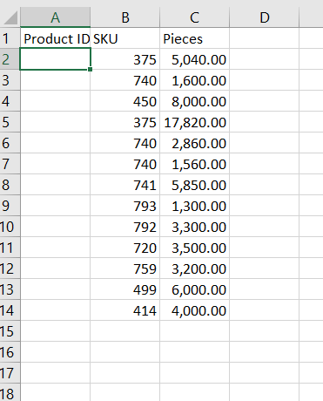

When you have a file in the correct format, click import and you will be prompted to choose an input file:

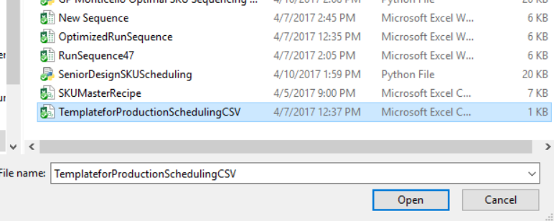

# Step 2: Obtain Optimal Run

Once the orders have been inputted, your window should look like this:

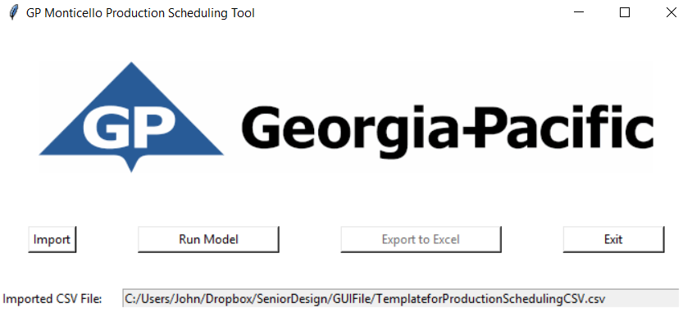

To obtain the optimal run, click run model, and the run will be shown below the file path.

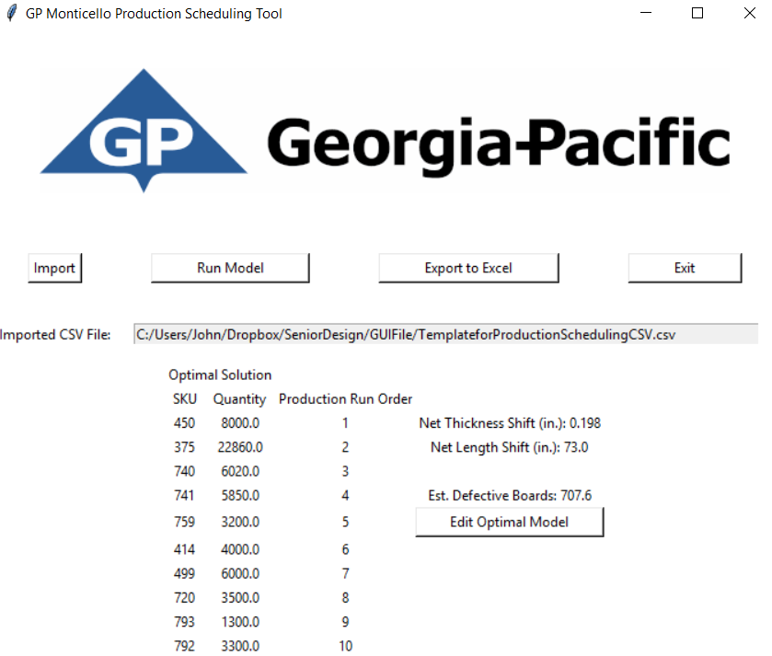

# Step 3: Export Model

Here you have two options: Option 1 is to export to an excel file directly (click Export to Excel), Option 2 is to click Edit Optimal Model and create a custom sequence.

Option 1:

After clicking Export to Excel you will be prompted to give a file name for your run:

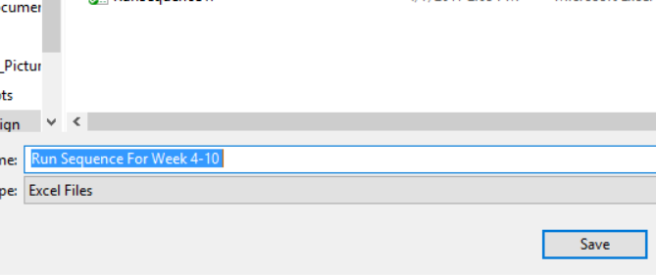

Click save and you’re done! Exit the application, and the file will be saved in your selected directory.

# Optional: Editing the Run

If you choose to edit the sequence, you will be prompted to input the order you would prefer they be run:

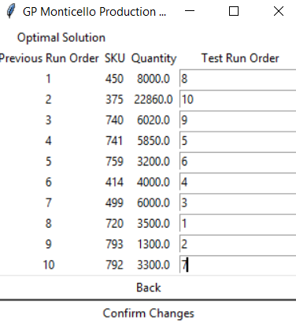

After clicking Confirm Changes, your new sequence will be shown with the estimated number of defects:

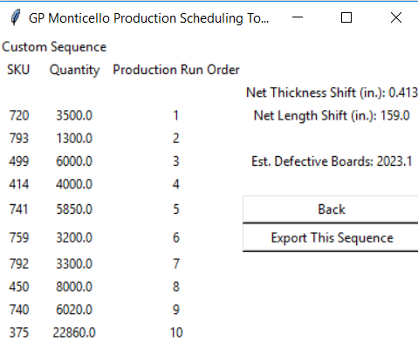

If you want to use this sequence instead, click Export This Sequence, and follow the steps described under Step 3.